All India Shri Shivaji Memorial Society 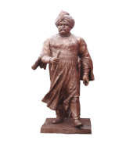
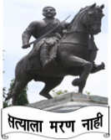
55- 56, Shivajinagar, Pune – 411 005

INVITATION FOR QUOTATIONS

All India Shri Shivaji Memorial Society’s Private Industrial Training Institute, Boribhadak, Tal – Daund, Dist- Pune, Pin 412202 requires Machinery, Tools & Equipments, Software, Consumables, Raw Material, Furniture etc. Sealed & signed tenders are invited in two bid System by offer method from eligibale & registered firms. Details regarding specifications, quantity and other terms & conditions are available in the office of the aforesaid Institute. Quotations should reach the “Vice –Principal, AISSM Society’s Private Industrial Training Institute , Boribhadak, Tal. Daund , Dist- Pune, Pin-412202” within Seven (7) days from the date of publication of the advertisement.

Date: 5-12-2015 Malojiraje Chhatrapati
Honorary Secretary

